# **HandsMen Threads: Elevating the Art of Sophistication in Men's Fashion**

## **Abstract**

This project presents the implementation of a customized Salesforce CRM solution for **HandsMen Threads**, a premium men's fashion and tailoring brand.  
 The objective was to streamline business operations, enhance customer engagement, and maintain data integrity across departments.

The solution involves designing a robust data model featuring five key custom objects: **Customer, Order, Product, Inventory, and Marketing Campaign**. Business processes were automated using **Record-Triggered Flows, Scheduled Flows, Email Alerts, and Apex** to handle order confirmations, loyalty status updates, and proactive stock alerts.

To ensure clean and reliable data, **validation rules** were established, and a **role-based security model** was implemented for the Sales, Inventory, and Marketing teams. The solution also includes a **scheduled batch job using Apex** to update low stock quantities.

This end-to-end CRM implementation improves customer experience through personalized communication, ensures operational efficiency with automation, and lays a scalable foundation for future business growth using the Salesforce Platform.

## **Objective**

The main objective of this project is to develop and implement a customized Salesforce CRM solution for HandsMen Threads to:

* Streamline core business operations.
* Maintain data integrity.
* Enhance customer satisfaction.

### **Specific Goals:**

* Automate key processes such as order confirmations, loyalty status updates, and stock alerts.
* Ensure accurate and consistent data entry using validation rules.
* Enable real-time visibility of inventory and customer interactions.
* Improve internal team coordination through role-based access control.
* Deliver personalized customer experiences through targeted communication and loyalty programs.

## **Technology Description**

### **Salesforce**

Salesforce is a cloud-based Customer Relationship Management (CRM) platform that helps businesses manage customer data, automate processes, and improve service, marketing, and sales operations. It provides **point-and-click tools** as well as **programmatic capabilities (Apex and Flows)** to build custom business solutions.

### **Custom Objects**

Objects in Salesforce are like tables in a database. **Custom Objects** are created to store business-specific data.  
 **Examples:**

* **Customer__c** – Stores customer information.
* **Product** __c– Stores product details.
* **Order** __c– Stores order details.
* **Inventory__c** – Tracks stock.
* **Marketing_Campaign__c** – Stores campaign details.

### **Tabs**

Tabs display object data in the Salesforce UI for easy access.  
 **Example:** A Product tab for managing product records.

### **Custom App**

A Salesforce App is a collection of tabs grouped for a specific business purpose.

### **Profiles**

Profiles define user permissions such as object access, field access, and app visibility.

### **Roles**

Roles control data visibility and define hierarchy-based sharing and reporting.

### **Permission Sets**

Permission Sets provide additional permissions without modifying profiles.

### **Validation Rules**

Ensure correct and meaningful data entry.  
 **Examples:**

* Email must contain **@gmail.com**.
* Stock cannot be negative.

### **Email Templates**

Predefined email formats for customer communication.  
 **Examples:**

* "Order Confirmation" template.
* "Low Stock Alert" template.

### **Email Alerts**

Send automated emails using predefined templates.  
 **Example:** When loyalty level changes, send a status update email.

### **Flows**

Automation tools to create, update, or notify users without writing code.  
 **Example:** Trigger an email when a new order is confirmed.

### **Apex**

Salesforce’s object-oriented programming language for complex business logic.  
 **Example Triggers:**

* Update Total_Amount__c in orders.
* Reduce inventory stock on order creation.

## **Project Execution Phases**

### **1. Developer Org Setup**

* Created a Salesforce Developer Org using <https://developer.salesforce.com/signup>.
* Verified the account and accessed the Salesforce Setup page.

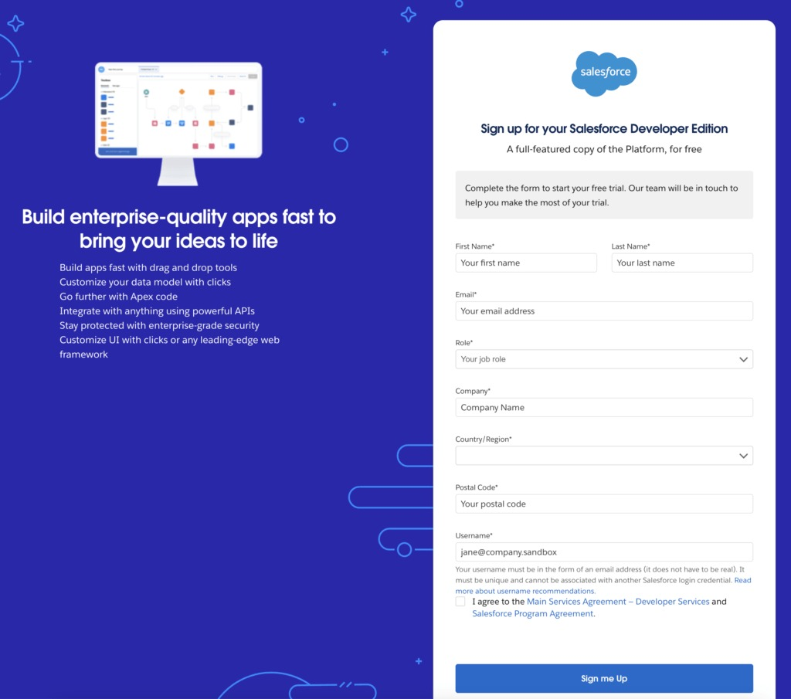

### **2. Custom Object Creation**

Five custom objects were created:

* **Customer** – Email, phone, loyalty status.
* **Product** – SKU, price, stock details.
* **Order** – Quantity, status, total amount.
* **Inventory** – Stock and warehouse location.
* **Marketing Campaign** – Promotion details.

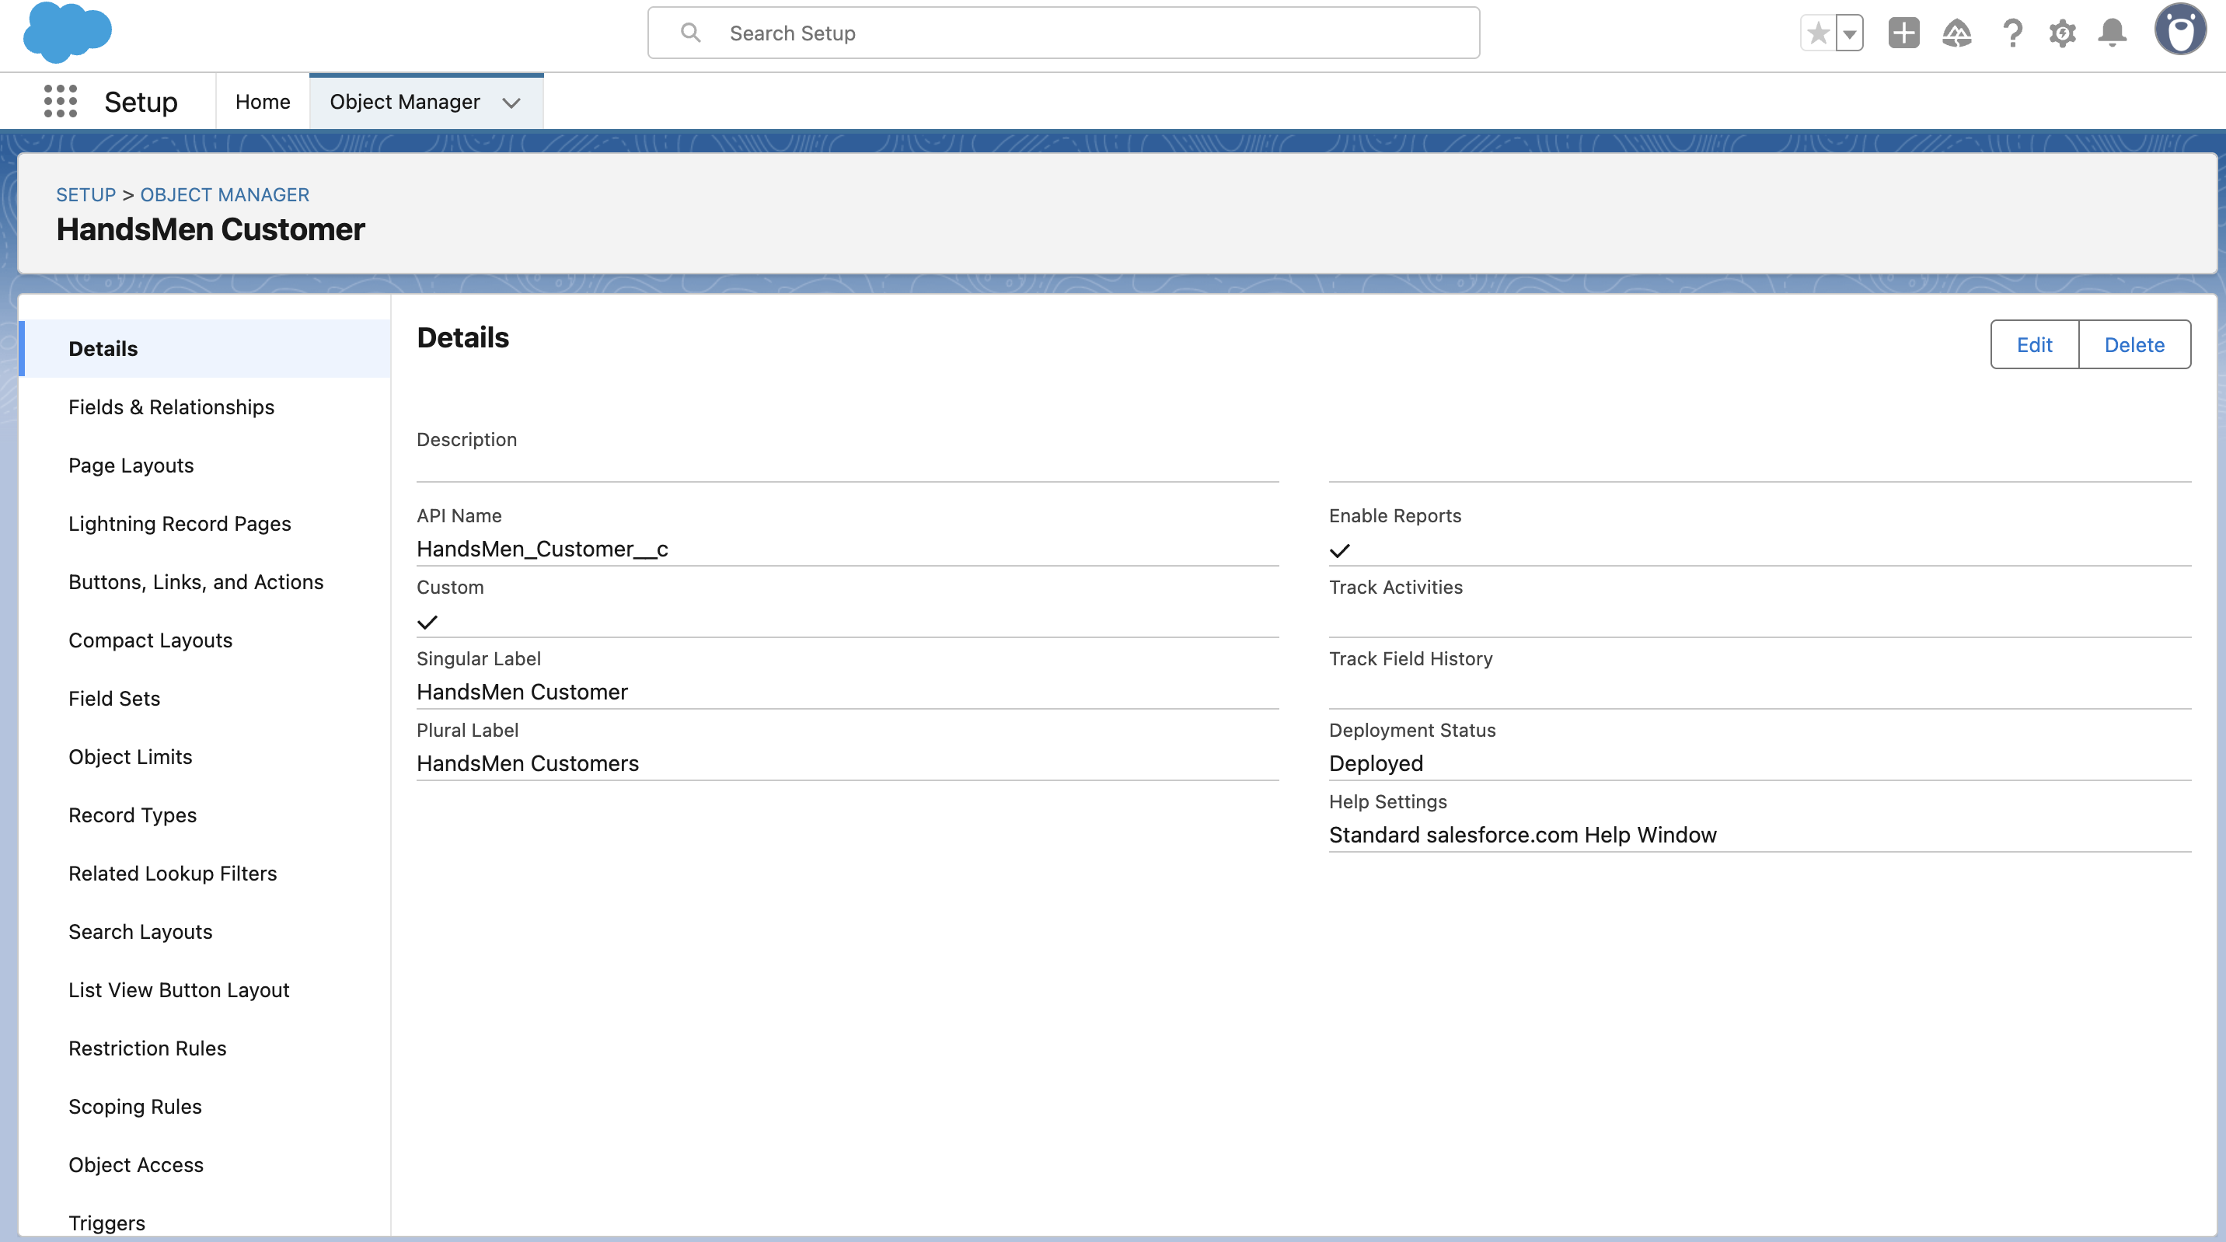

### **3. Lightning App Creation**

* Created **HandsMen Threads App**.
* Added tabs: Customer, Order, Product, Inventory, Marketing Campaign, Reports.
* Assigned the app to the **System Administrator** profile.

### **4. Validation Rules**

Examples:

* **Order Object** → Total Amount must be > 0.
* **Customer Object** → Email must contain @gmail.com.

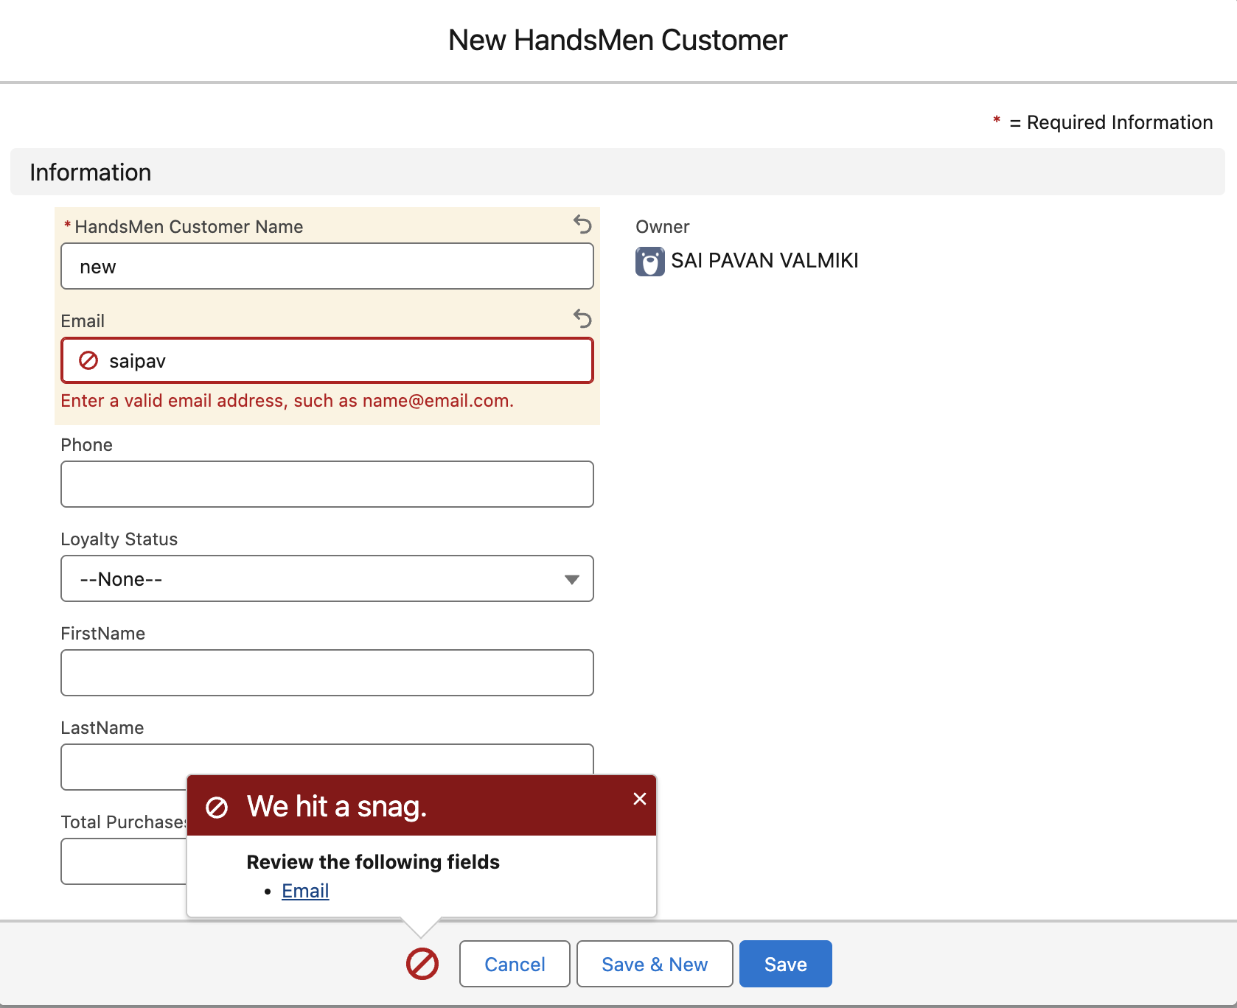

### **5. User Roles & Profiles**

* Cloned the Standard User profile to create **Platform 1 Profile**.
* Created roles: **Sales Manager**, **Inventory Manager**, **Marketing Team**.

### **6. User Creation**

Examples:

* **Niklaus Mikaelson** – Sales Role.
* **Kol Mikaelson** – Inventory Role.

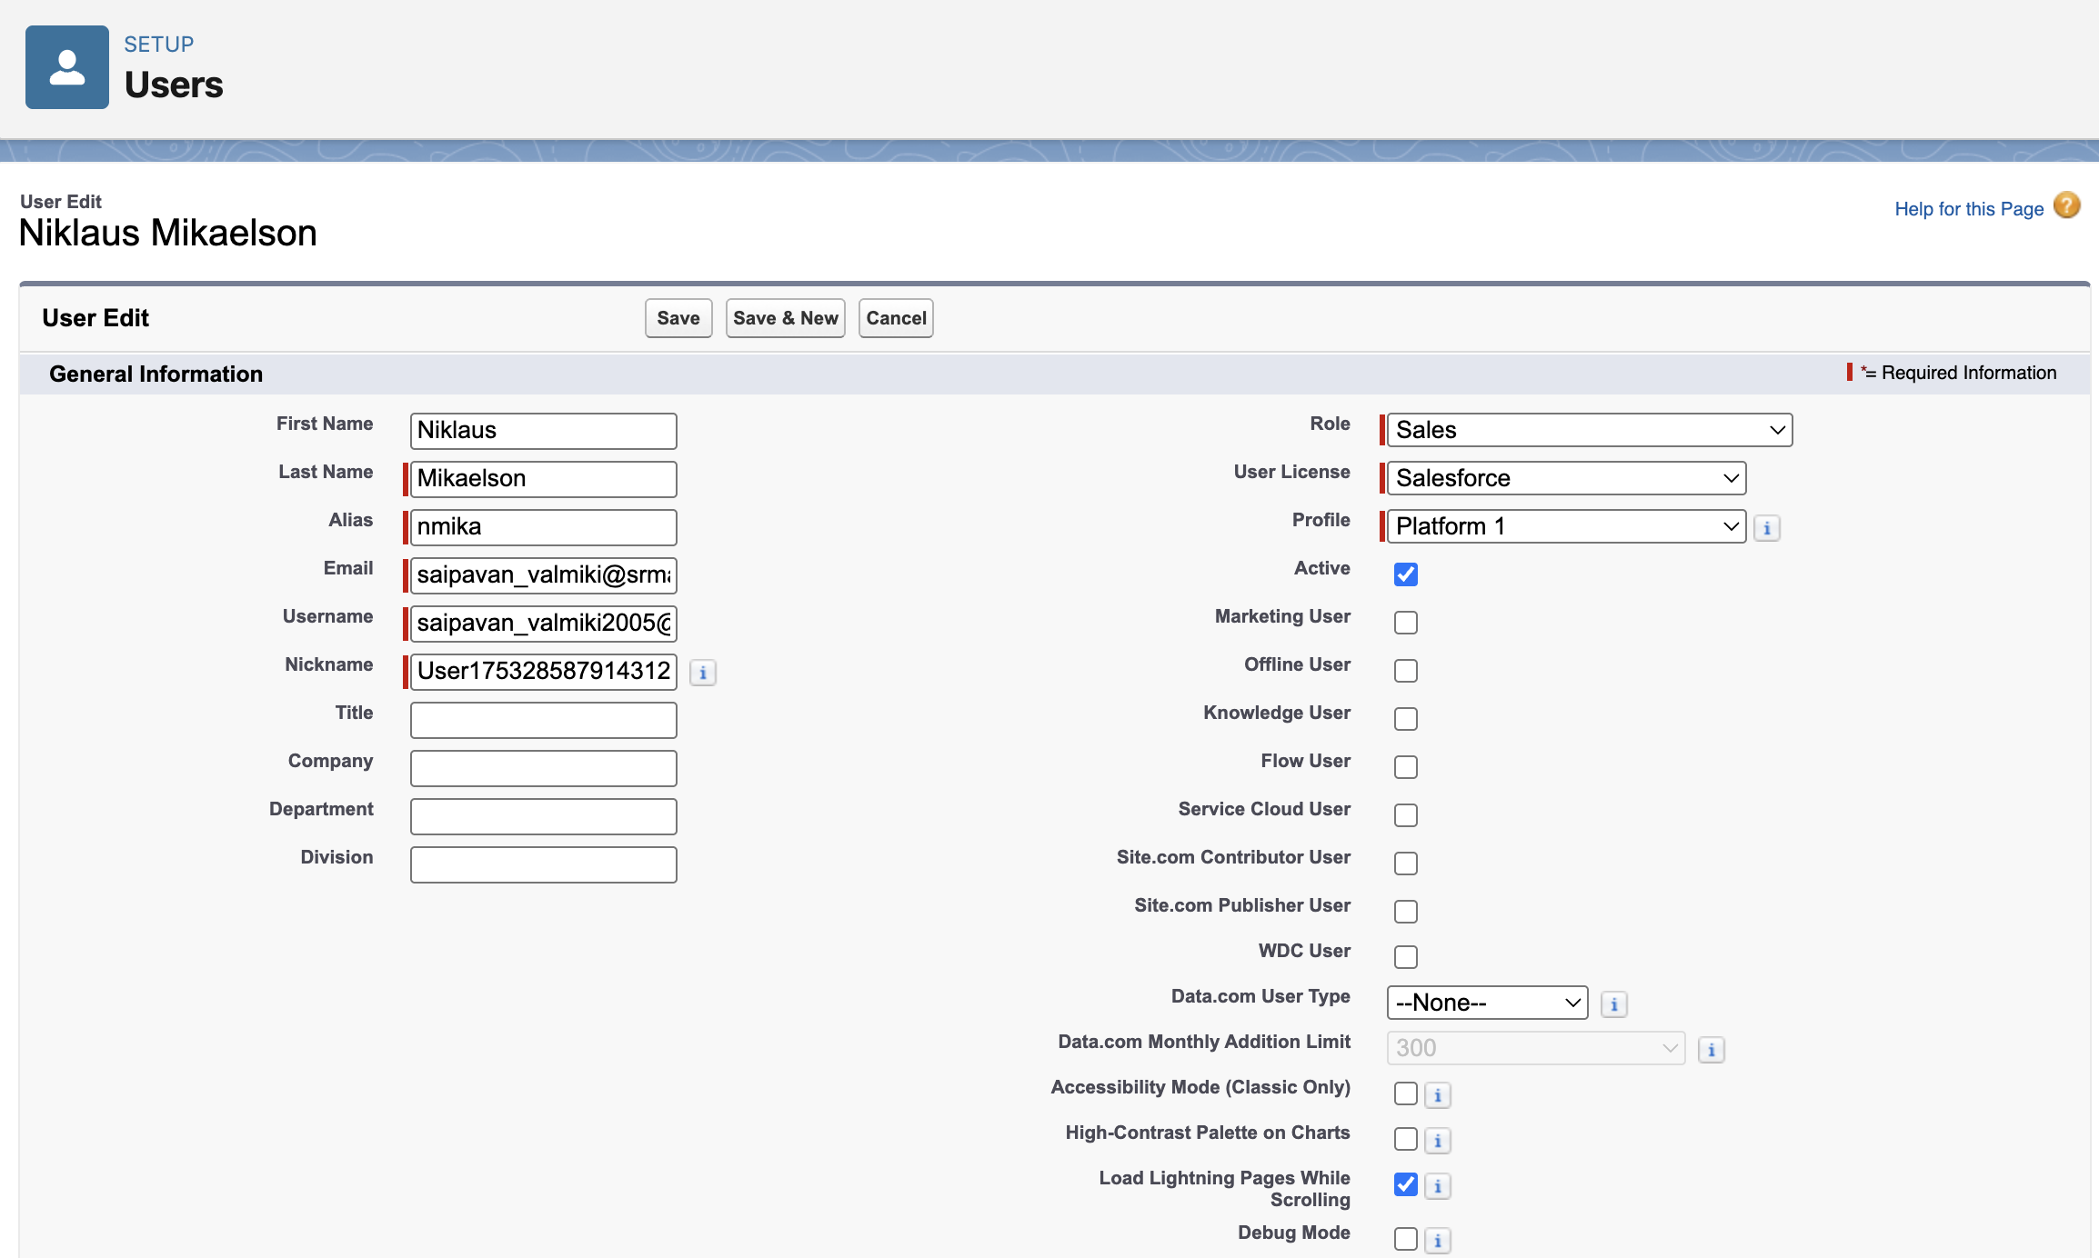

### **7. Email Templates & Alerts**

* **Order Confirmation Email** (sent on order status = Confirmed).
* **Low Stock Alert** (sent when inventory < 5).
* **Loyalty Program Email** (sent on loyalty status change).

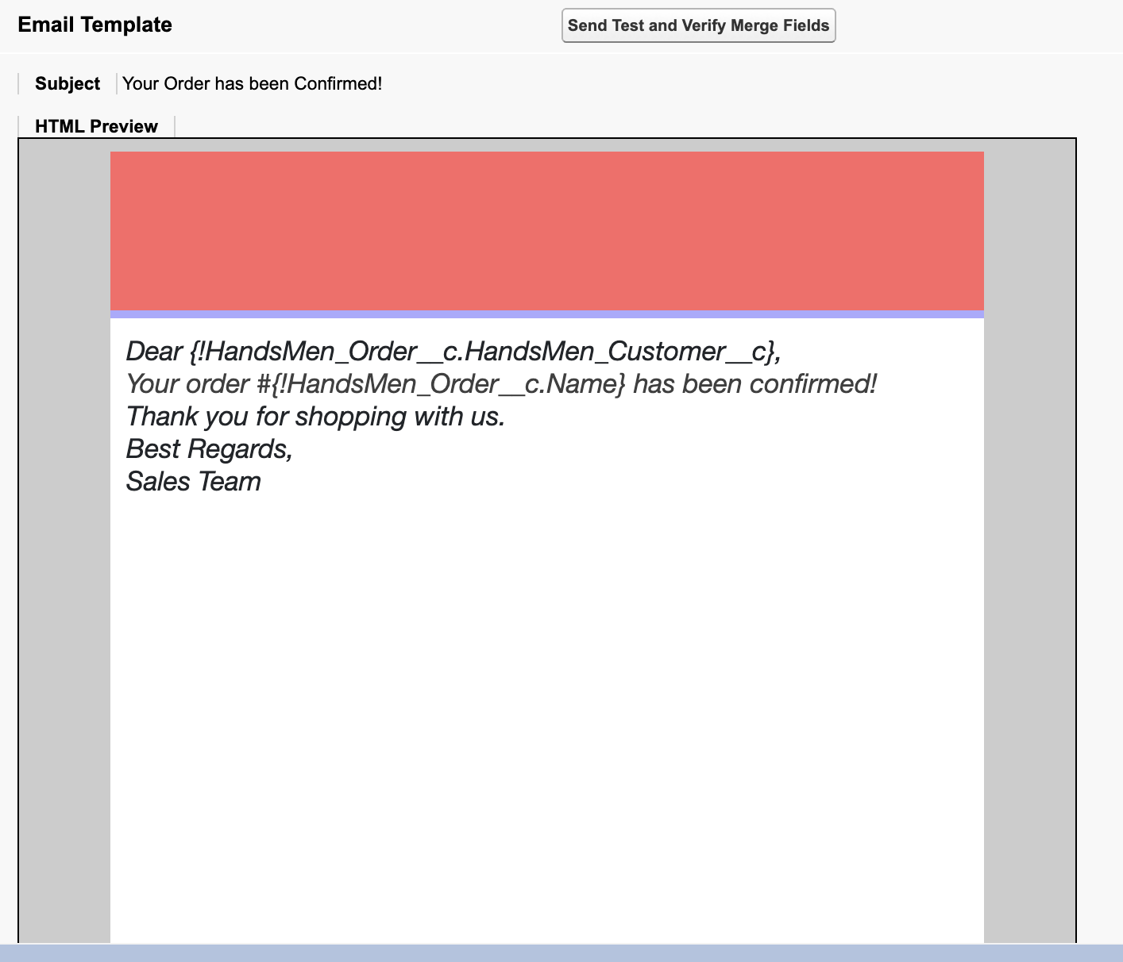

### **8. Flows**

* **Order Confirmation Flow** → Sends email on confirmation.

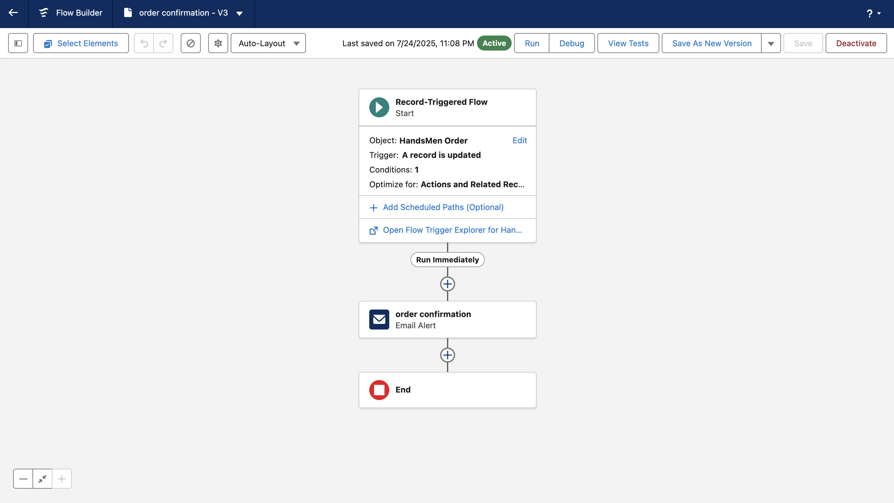

* **Stock Alert Flow** → Sends email when stock < 5.

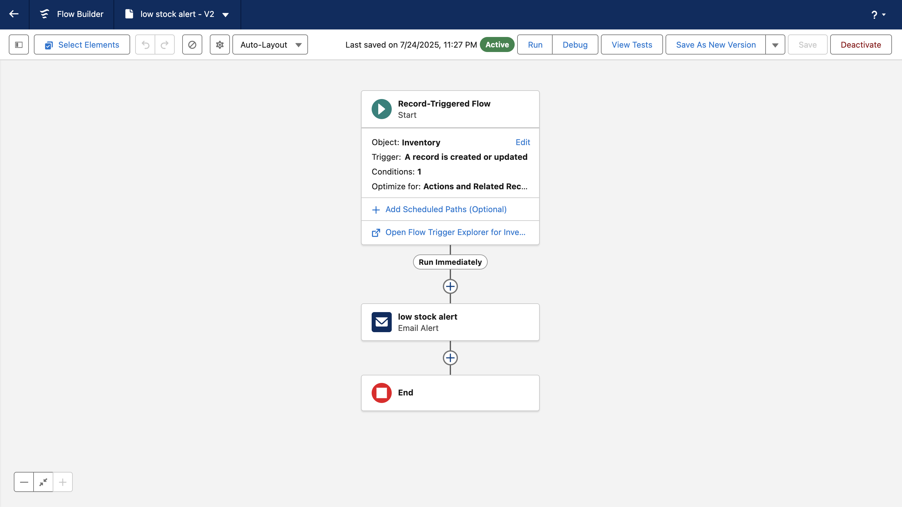

* **Scheduled Flow (Loyalty Update)** → Runs daily to update loyalty status.

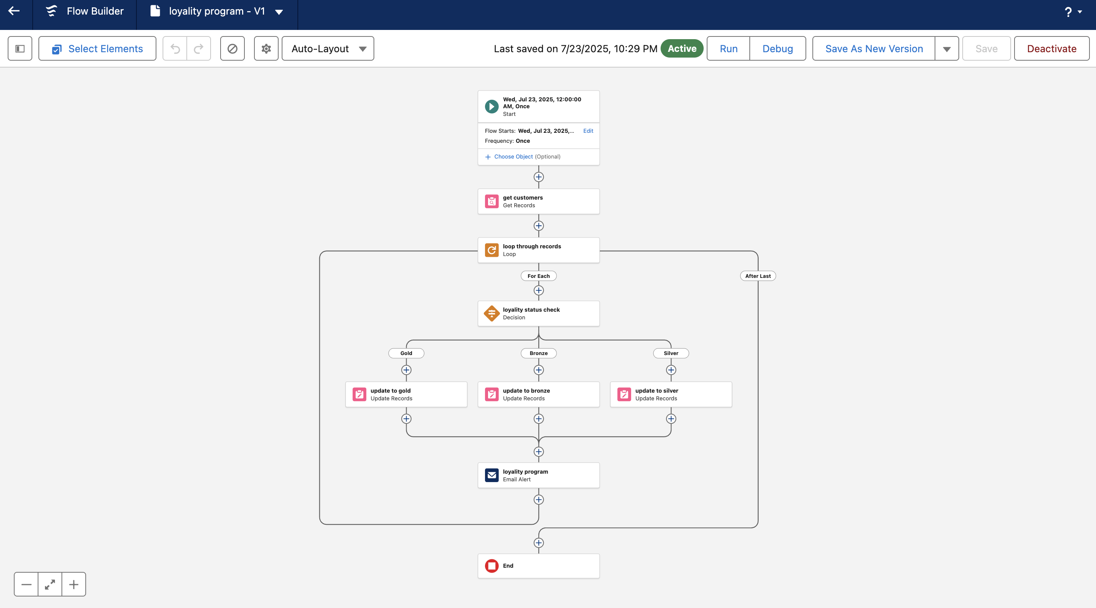

### **9. Apex Triggers**

* **Order Total Trigger** → Calculates total amount.
* **Stock Deduction Trigger** → Reduces stock after purchase.
* **Loyalty Status Trigger** → Updates loyalty level automatically.

## **Real-World Example**

1. **Customer Registration:**

* Customer record created (e.g., Virat Mikaelson).
* Email validation ensures correct email format.

1. **Product Setup:**

* Admin adds Shirts and Jeans.
* Inventory maintained for stock.

1. **Order Placement:**

* Virat orders 2 shirts at ₹500 each.
* Apex auto-calculates total amount ₹1000.

1. **Inventory Update:**

* Stock reduces by 2 automatically.

1. **Loyalty Program:**

* Loyalty level changes to Silver based on ₹1000 total purchase.

1. **Email Notifications:**

* Confirmation and loyalty update emails are triggered.

1. **User Access:**

* Staff have appropriate roles and permissions for secure operations.

## **Screenshots**

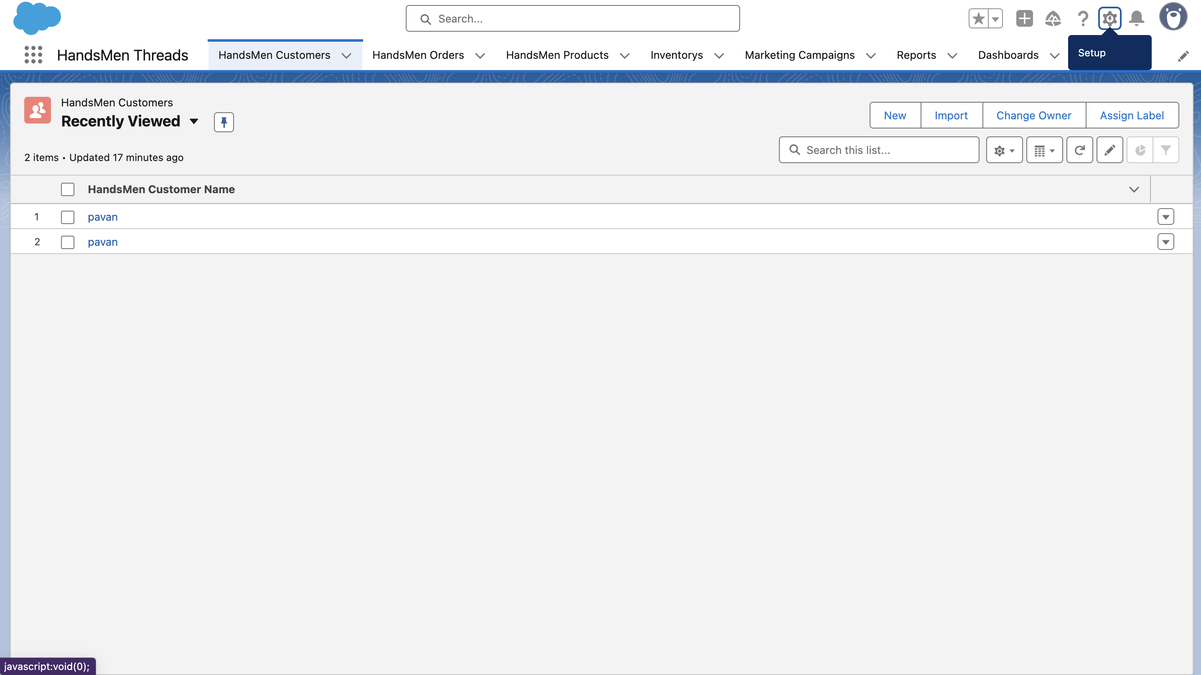

**Fig: Custom App for HandsMen Threads**

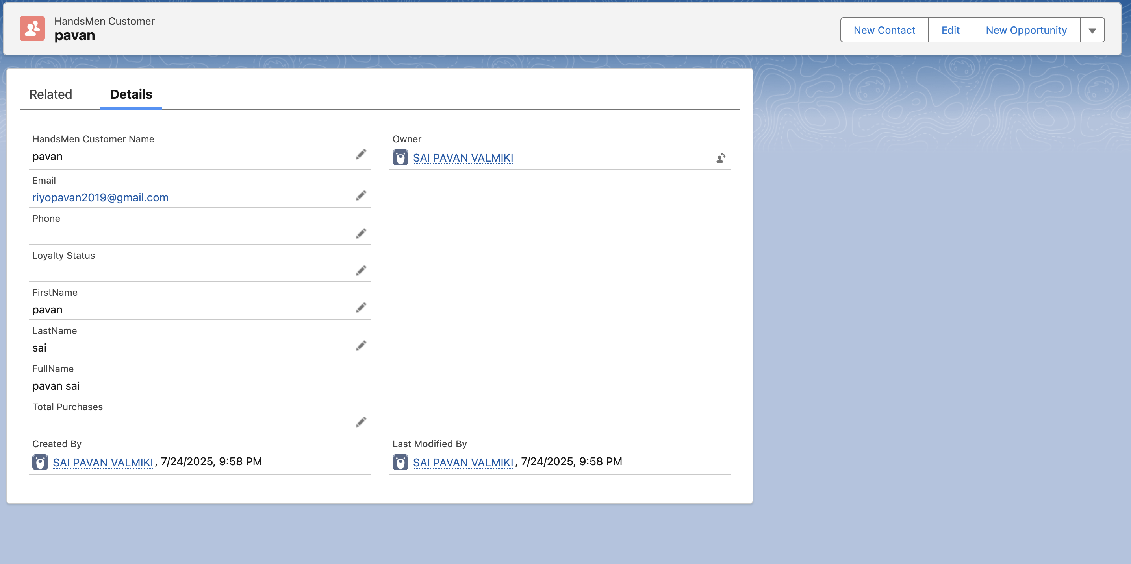

**Fig: Customer Creation in HandsMen THreads**

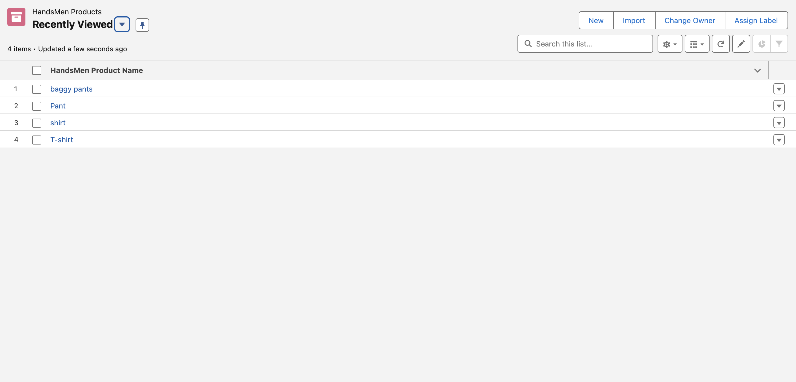

**Fig: Products in HandsMen THreads**

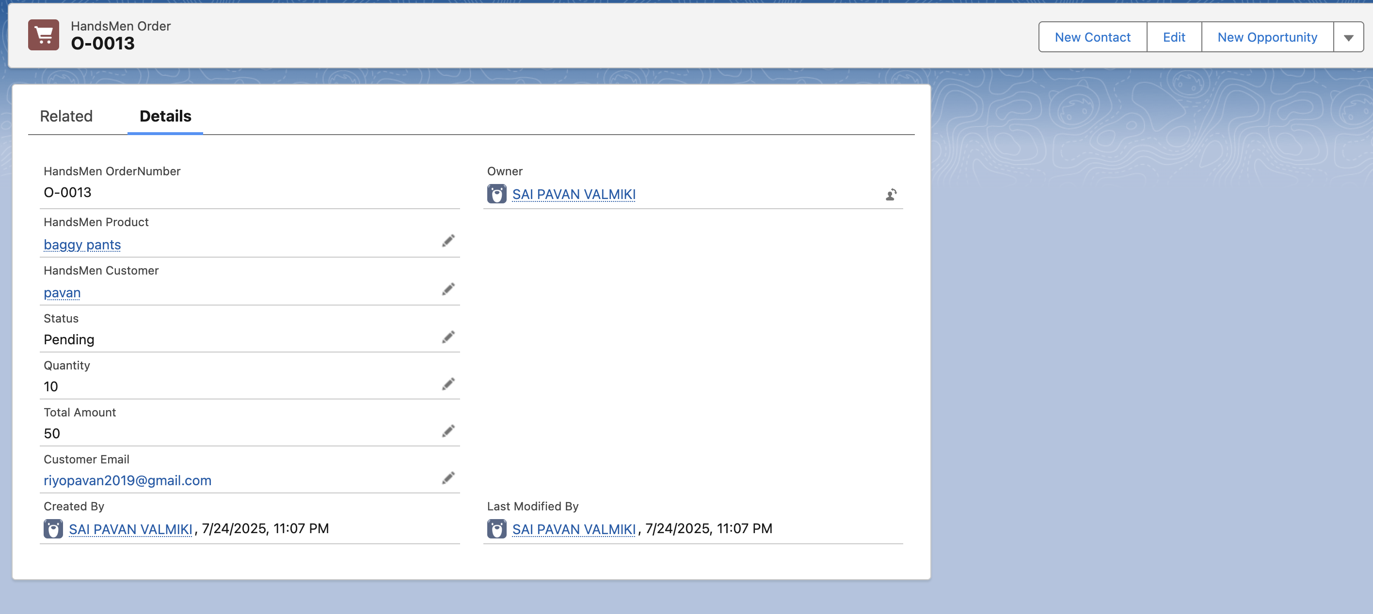

Fig: Order Confirmation

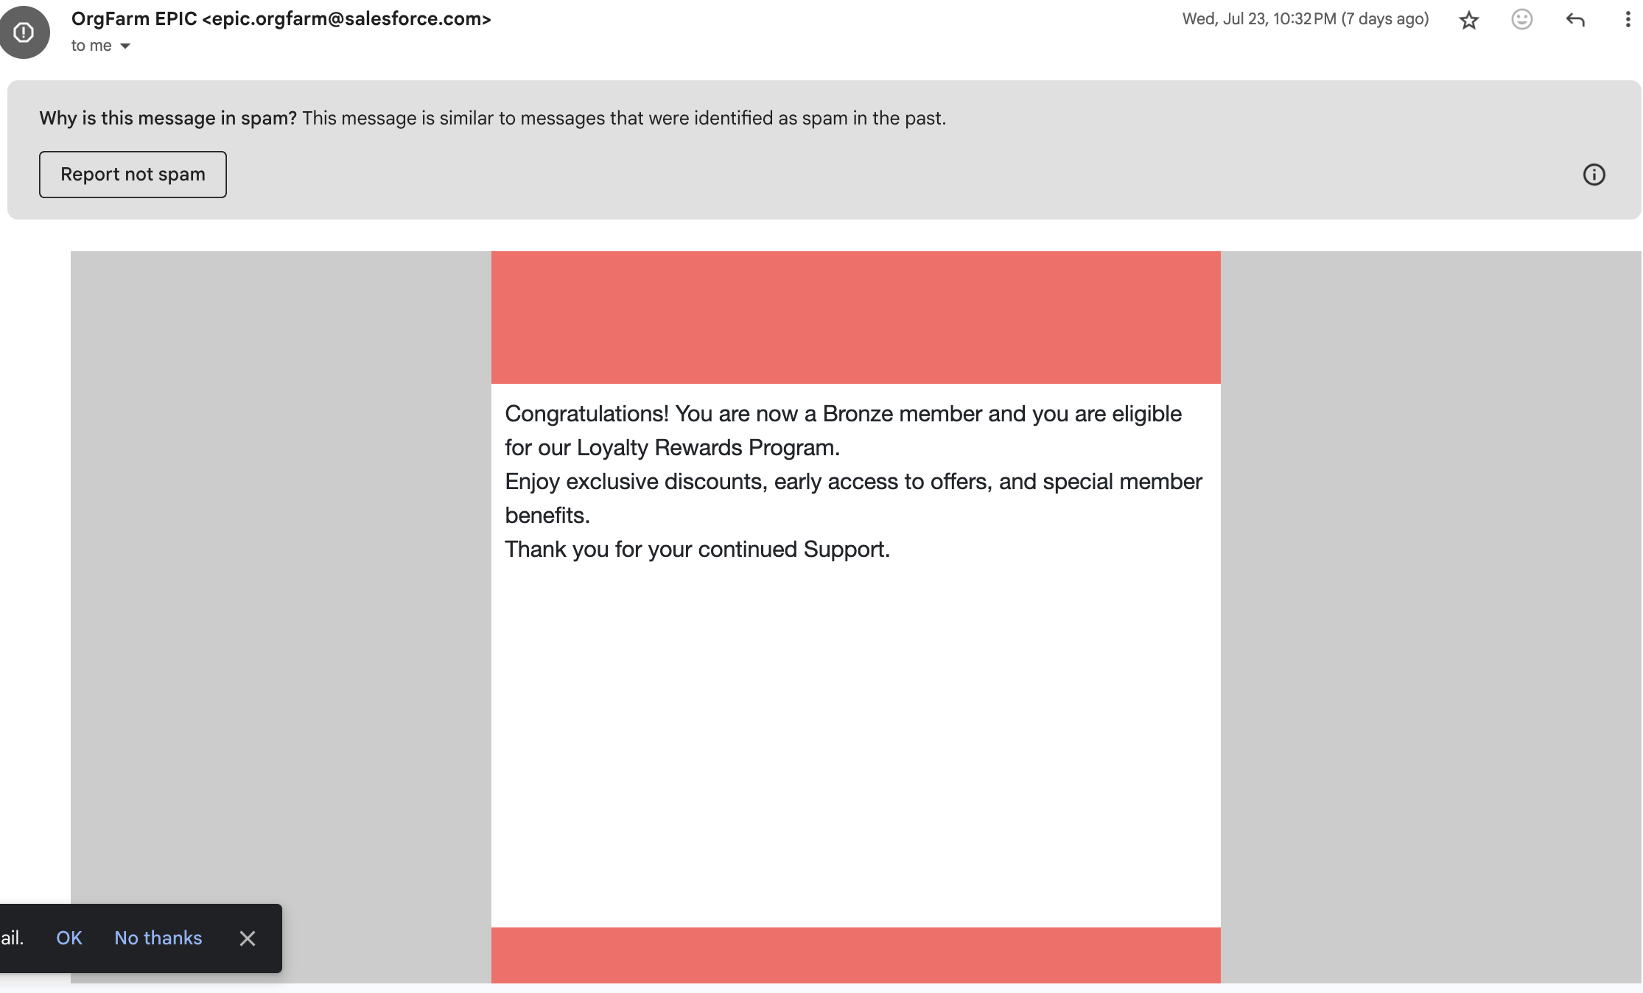

Fig: Loyality Program Email

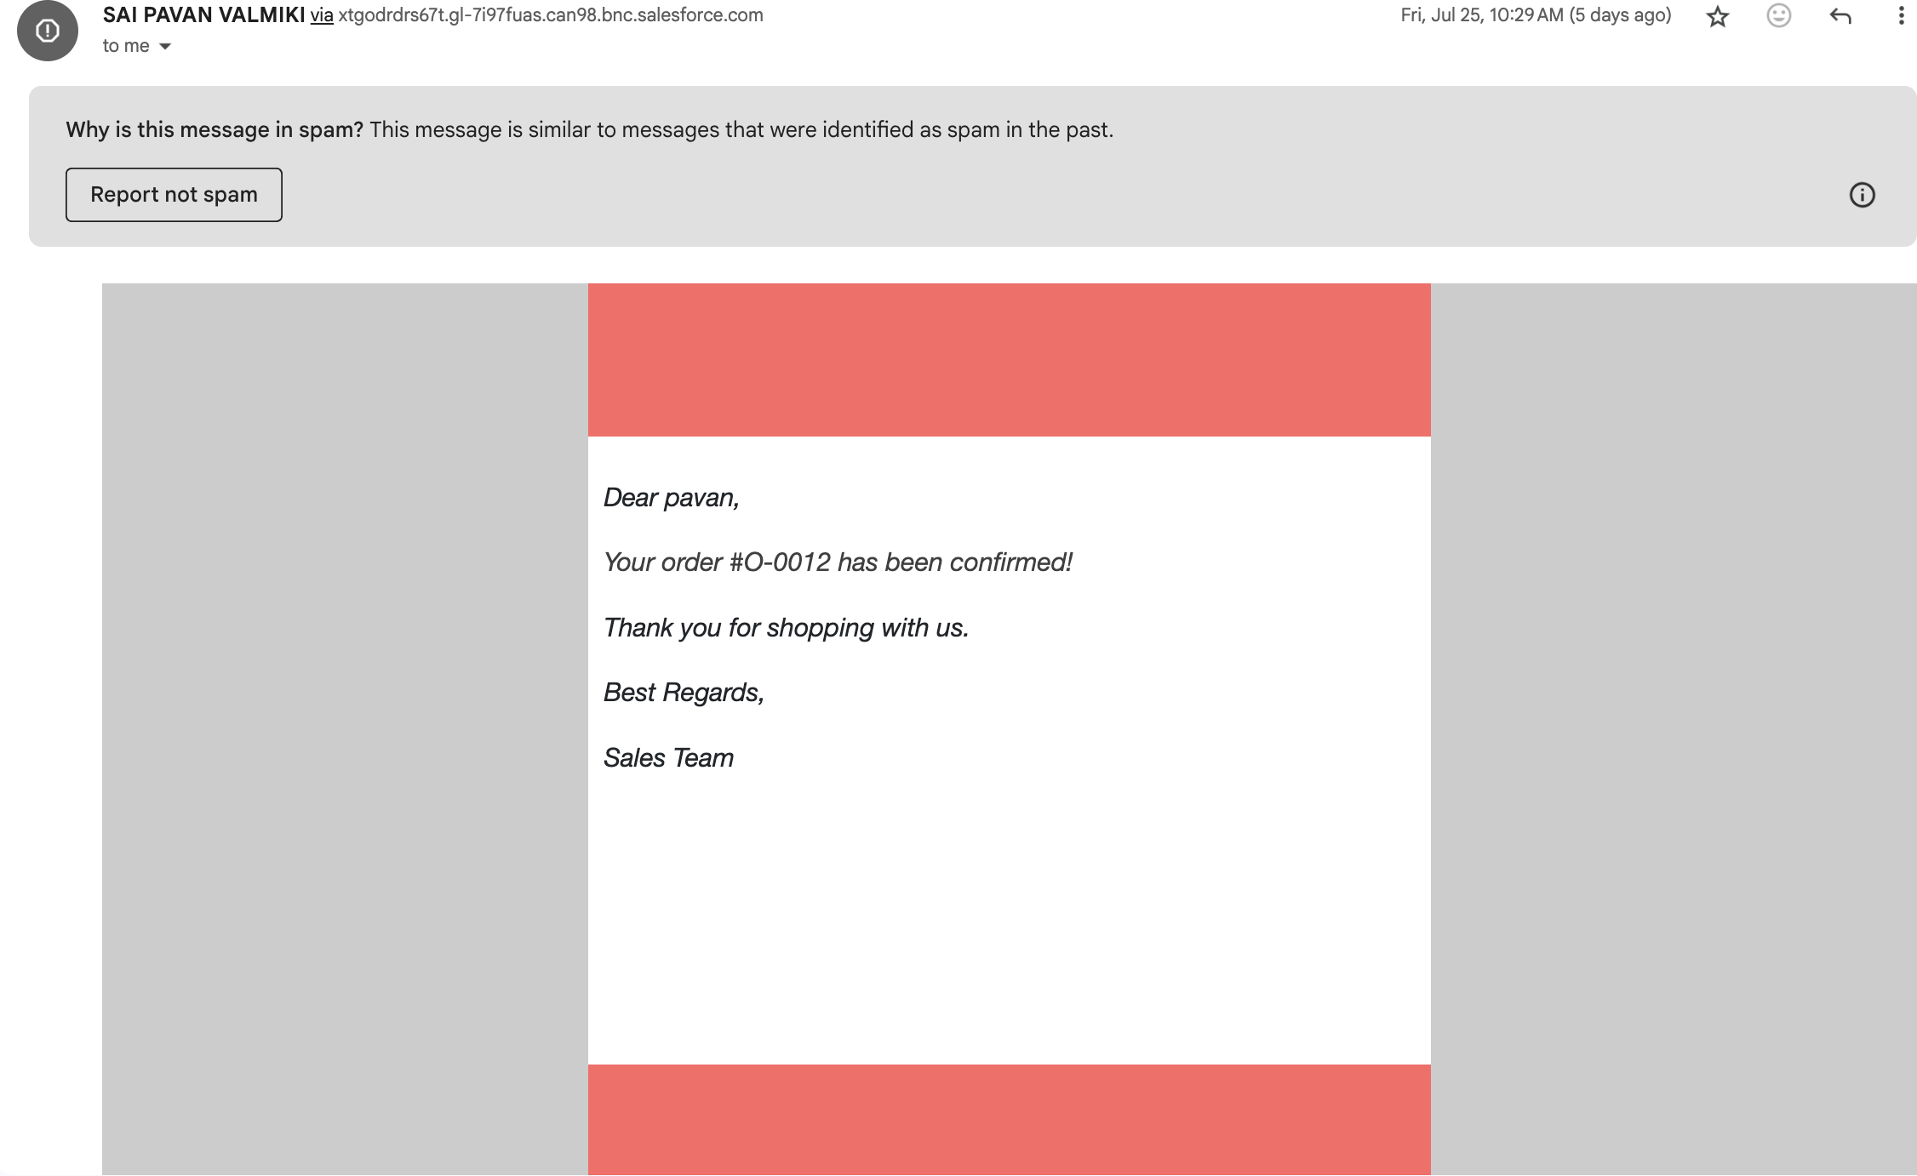

Fig: Order Confirmation Email

## **Conclusion**

The Salesforce CRM solution for HandsMen Threads successfully automates **customer management, product cataloging, order processing, inventory tracking, and loyalty programs**.  
 Key benefits:

* Accurate data entry.
* Automated business processes.
* Role-based security and access control.
* Improved customer experience through personalized communication.

## **Future Scope**

1. **Customer Portal Integration** – Allow customers to view orders and loyalty status.
2. **Mobile App (Salesforce Mobile SDK)** – Enable on-the-go inventory and order management.
3. **Reports & Dashboards** – Real-time insights for sales and stock performance.
4. **AI-Powered Recommendations (Salesforce Einstein)** – Personalized product suggestions.
5. **WhatsApp/SMS Integration** – Real-time order and loyalty notifications.